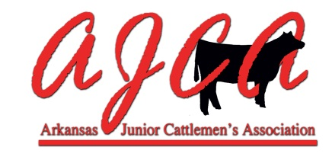
2016-2017 Sanctioned
Show Management Procedures

- A sanctioned show must be open to all youth in Arkansas age 20 or under (as of October 1, 2016).

- AJCA sanctioned shows are required to announce the judge(s) at least 7 days before the show. Shows not following this requirement will not be sanctioned the following year. Email the judges name to arkansasjrcattlemen@gmail.com for publication on the AJCA website two weeks prior to your show. You may also call AJCA State Director, Michelle Rieff at 479.936.1685.

- Show management will be responsible for keeping accurate records of their show placings. They will also be responsible for submitting the information to the AJCA points administrator as indicated on the website. POINTS MUST BE SUMBITTED ON THE OFFICIAL AJCA POINTS/PLACINGS REPORTING FORM. Points not submitted on the OFFICIAL reporting form will NOT be accepted and will be sent back to show management to be resubmitted. The AJCA point paperwork must be received within ten working days of the conclusion of the show. The information must include exhibitor names, classes, placings, and the number of animals in each class. It would be helpful to the AJCA point’s administrator to include each AJCA member’s membership number if available.

- Exhibitors must own the animal(s) they exhibit unless an exhibitor has multiple animals in ring(s) at the same time. Points will NOT be awarded if the exhibitor does NOT own the animal(s). Exceptions to this rule will be given in writing and be granted only by the AJCA State Director for extenuating circumstances.

- To be uniform and consistent, sanctioned shows will use the following AJCA guidelines:
  - Using the month of birth, no animals will be allowed to show before the age of six months or past two years of age. Use the month for determining eligibility – not the actual date of birth. For example, if a heifer’s birthdate was March 1, she could show through the month of March. Another example - a heifer that would not turn six months old until March 30 would be eligible to show in an event on March 1.
  - Breeding bulls and females will be broken into classes by no more than two months.
  - Bulls will be shown with their breed. Please refer to the list of AJCA approved breeds.
  - Steers should be divided to make workable classes, preferably using weight and/or hip height measurement.
  - Commercial heifers are defined as any female not registered with a breed association. Commercial heifers will be divided into three divisions to include American, English and Exotic crosses. Exhibitors exhibiting commercial heifers not meeting criteria for their division, may be asked by the State Director for breeding genetics and to move to another more appropriate division. Further division by number, age, weight, etc. is at the show management’s discretion. Champion and Reserve commercial heifers will be selected from each division (American, English, and Exotic).
  - AJCA does NOT award points for Division Champions or Division Reserve Champions (breeding bulls, heifers and steers).
  - AJCA will award points on the top five overall breeding heifers (to include commercial heifers), top five bulls and top five steers. Show management may or may not award prizes, but top 5’s will be named at the conclusion of each division (breeding heifers, bulls and steers). A special form will be provided to show management to report results.
  - Bulls one year of age and older MUST be exhibited with a nose ring/nose clip and lead.
  - Ownership – Exhibitors that have not yet received registration papers will be allowed to show in their respective breed with a bill of sale. The Bill of Sale must include the date of sale, the seller’s name, the new owner’s name, the breed of the animal, the sex of the animal and the date of birth of the animal, and the tattoo # of the animal. The bill of sale will be sufficient for 45 days from the date of sale to allow the new owner to receive registration papers. It is not acceptable to allow a registered animal to show in the commercial show because the exhibitor does not have registration papers in hand. EXHIBITORS WILL NOT BE ALLOWED TO SHOW ON A BILL OF SALE AT THE ARKANSAS STATE FAIR SPRING LIVESTOCK SHOW. EXHIBITORS MUST HAVE REGISTRATION PAPERS SIGNIFING OWNERSHIP OF THE ANIMAL. THE ANIMAL MUST BE IN THE EXHIBITOR’S NAME. SEE ARKANSAS STATE FAIR SHOW RULES FOR CLARIFICATION.

- Animals used in showmanship classes must be owned by the exhibitor and be shown in class in addition to the showmanship division. The only exception is Pee Wee Showmanship. Pee Wee showmanship exhibitors do not have to own their animals. Showmanship contest division ages are ages as of OCTOBER 1, 2016
  - Pee Wee – 8 and under
  - Junior - 9-13 years old
  - Senior - 14 – 20

- Breed association shows or field days are open to those breeds announced.

- The AJCA will not be responsible for accidents or loss of property or the formulation or enforcement of individual show rules. These are the sole responsibility of the show management. It is the show management’s responsibility to enforce AJCA rules. Additional show rules MUST be posted. It is heavily suggested that additional show rules be submitted to the AJCA website administrator for publication prior to the show. At the discretion of show management, animals that cannot be controlled by the exhibitor (i.e. breaking away from the exhibitor more than 3 times during a class) may be removed from the arena with the exhibitor not receiving points.

- Shows should not use the word “jackpot” in their name unless the show plans to jackpot or pay out a percentage of entry fees. If the show is for points and/or prizes only, that information should be specified on the flyer so that exhibitors are aware ahead of time.

- After AJCA show point files are posted to the AJCA website, members have seven business days to dispute the report. At the end of seven business days, the points for that reporting period become final. Emails will be sent to members notifying them that a new point file has been posted. Members who find an error must follow this procedure:
- Contact the AJCA Point’s Administrator to report a possible discrepancy.
- Contact the particular show manager to resolve the discrepancy.
- Show management will contact the AJCA Point’s Administrator of any corrections.
- It is strongly suggested that the member follow up with the Point’s Administrator to assure the matter has been resolved.
- Violations of any rules listed will result in the loss of points to exhibitors as well as the possibility of the show being placed on probation and/or losing sanctioning rights for years to follow.

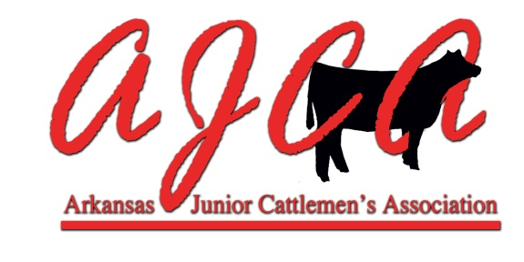

Show Management Checklist

BEFORE THE SHOW:

_____Visit www.ajcattle.com to become familiar with all rules
and regulations regarding AJCA sanctioned shows.

_____Print copies of necessary forms and make notations about information
needed from exhibitors (AJCA number, registration number, etc.)

_____Make copies of AJCA requirements/guidelines and any additional rules that apply to the show and post them at the registration table.

AT REGISTRATION:

_____Please record the exhibitor name and AJCA member number.
Correct spelling of names and correct AJCA numbers are
vital in reporting points correctly.

_____Please check registration papers for owner’s name, animal’s
date of birth, and ownership date. Checking current health
papers is highly recommended.

_____PLEASE record whether the animal is a heifer, bull, or steer
and make certain that the animal is in the correct division.

_____Break registered classes in two month intervals
(January/February, March/April, etc.) with the exception of
the youngest and oldest class (one month break).

_____Class breaks for commercial heifers and steers are at the
discretion of the show management.

_____Please record the names and ages of all exhibitors that
register for showmanship classes.

DURING THE SHOW:

_____Make certain that information (class placings, etc.) is
recorded as accurately as possible. If the show secretary is
unsure of an exhibitor name or class placing, please ask the
exhibitor, ring steward, or judge immediately.

_____Please record any possible rules violations noticed by the
show management. Also, please make notations about any
suspected rules violations that are reported to you by
exhibitors and/or spectators. This information may be
pertinent in points challenge situations.

_____During showmanship classes, please record the number of
exhibitors that ACTUALLY participate. This number may
vary from those registered. AJCA needs the exact number
of actual participants in each age division.

_____All showmanship classes should be placed 1st through 5th
place. AJCA awards points based on 1-5 placings only.

_____PLEASE record the Grand Champion and Reserve Champion
in each division. Important: Please report information on
heifers and bulls in each breed; commercial heifers by
American, English, and Exotic; and steers by Grand and
Reserve (not breed specific).

_____Write down any questions/concerns that you might have, no
matter how trivial they may seem at the time. Recording
these questions may help in a points challenge situation.

_____Provide the show secretary with a copy of AJCA requirements/guidelines rules to help answer any questions that may arise.

AFTER THE SHOW:

_____Paperwork for AJCA points should be RECEIVED by AJCA within ten working
days of the conclusion of the show.

_____Use the AJCA Official Sanction Show Placing/Report Form
available at www.ajcattle.com to report show results
to the AJCA Points Administrator.

_____REQUIRED information should include Exhibitor name, AJCA
number (if known), classes, placings, and number of animals
in each class and/or division.

_____When filling out the points Show Placing/Report Forms, please use a
separate sheet for each breed or division. It is also preferred
that heifers and bulls are listed on separate sheets.

_____Please list only the top 5 showmanship placings on the
Showmanship Report. It is very important that AJCA knows
the number of actual participants in each age division.

_____Please indicate the Grand and Reserve Champion heifer in
each of the commercial divisions—American, English, and
Exotic.

_____AJCA does not award points for Supreme Grand, Supreme
Reserve Champions or Division Champions or Reserve
Division Champions (breeding bulls, heifers, and steers).

_____A Rules Infringement/Special Circumstances form may be
submitted with the Show Placing Report Forms at the discretion of the
show management.

_____Please fill out all forms as accurately and neatly as possible.
Do not forget to include a contact person who has
knowledge of the show and can provide clarification or
additional information in a points challenge situation.

SUBMITTING SHOW POINTS/PLACING REPORTS:

Please contact Lisa Sigmon for assistance in filling out Show Points/Placing Report Forms.

All reports should be mailed to:

Lisa Sigmon, AJCA Points Administrator
1418 CR 708
Berryville, AR 72616

Other contact information:

sigmonsimmentals@yahoo.com
870.423.8723

A special thank you to all of the volunteers and show management who dedicate their time and talents to provide AJCA sanctioned shows for the youth of Arkansas. The members of the Arkansas Junior Cattlemen’s Association are truly appreciative of your efforts!

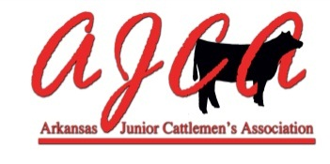
Showmanship Results Report

Show/Place/Date__________________________________________________

Contact Person________________________Email_______________________

Phone # Daytime_______________________Evening_____________________

All Showmanship Ages Based on age as of October 1, 2016.

Wee Jr. Division: 8 & Under Total Number in Division: _______________
Name: | AJCA Number | Placing:
 |  | 1
 |  | 2
 |  | 3
 |  | 4
 |  | 5

Jr. Division: 9-13 years old Total Number in Division: _______________
Name: | AJCA Number | Placing:
 |  | 1
 |  | 2
 |  | 3
 |  | 4
 |  | 5

Sr. Division: 14-20 years old Total Number in Division: _______________
Name: | AJCA Number | Placing:
 |  | 1
 |  | 2
 |  | 3
 |  | 4
 |  | 5
Please submit this report with AJCA Official Sanction Show Points/Placing Form
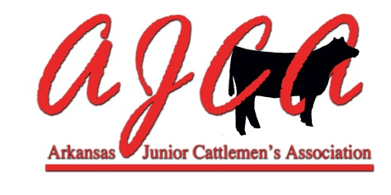
Rules Infringements/Special Circumstances

Show/Place/Date__________________________________________________

Contact Person ________________________Email_______________________

Phone # Daytime _______________________Evening_____________________

This document is intended to help the show management make AJCA aware of any possible rules infringements/violations or any special circumstances that may occur during the show. Information listed here may be helpful during a points challenge situation.

Please list any possible rules infringements or violations noticed by the show management and explain the situation as clearly as possible:

Please list any special circumstances or issues that might affect awarding points to any exhibitor:

Please submit this report with AJCA Official Sanction Show Points/Placing Forms
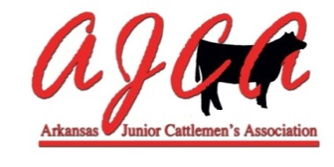
Top 5 Steers, Heifers & Bulls (Supreme Drive) Results Report

Show/Place/Date__________________________________________________

Contact Person________________________Email_______________________

Phone # Daytime_______________________Evening_____________________

MARKET STEERS Total Number of Steers in Show: _______

Exhibitor Name: | AJCA Number
1

2

3

4

5

BREEDING HEIFERS Total Number of Breed Champions in Supreme Drive: ____

Exhibitor Name: | AJCA Number | Breed
1

2

3

4

5

BULLS Total Number of Breed Champions in Supreme Drive: ____

Exhibitor Name: | AJCA Number | Breed
1

2

3

4

5

Please submit this report with AJCA Official Sanction Show Points/Placing Form

