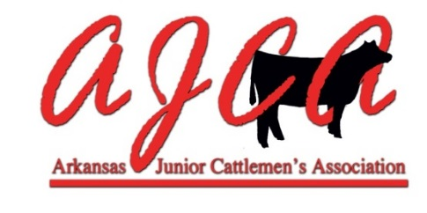
Recognized Breeds List 2016-2017

Registered Heifers & Registered Bulls
AOB
Angus
Beefmaster
Brahman
Brangus
Charolais
Chianina
Hereford
Limousin
Maine Anjou
Red Angus
Santa Gertrudis
Shorthorn
Simmental

Registered Composite Heifers & Bulls
Charolais Plus
Lim-Flex
Mainetainer
Shorthorn Plus
SimSolution

Commercial Heifers
American Commercial
English Commercial
Exotic Commercial

AJCA bases breed divisions after the Arkansas State Fair breed show list.

ASF BREED SHOW REQUIREMENTS: A breed show must have a minimum of ten animals shown by at least two exhibitors in order to qualify for an official show. Any breed listed in the current premium list that has less than ten head will show in AOB the following year. If a breed in AOB has ten head or more shown by at least two exhibitors they will qualify for a breed show the following year.

