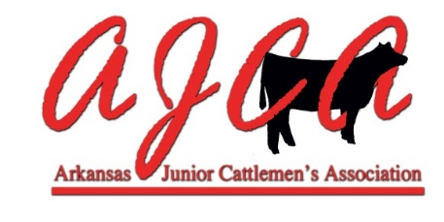
2016-17 REQUEST TO SANCTION AN AJCA SHOW

In order to request to sanction an AJCA show, the following application and $100 must be submitted to the AJCA State Director by December 15, 2016. Checks should be made payable to AJCA.

Name of Show: _____________________________________________________________

FIRST DATE CHOICE _________________________________________

SECOND DATE CHOICE _________________________________________

THIRD DATE CHOICE _________________________________________

Location of Show: _____________________________________________________________

Show Coordinator Name: ________________________________________________________

Telephone: ____________________________Email: _________________________________

Mailing Address: _____________________________________________________________

City: ______________________________________________________Zip: _____________

Website Address of Show (if available): ___________________________________________

In requesting to sanction an AJCA Show, I agree to follow the 2016-20167AJCA Sanctioned Show Guidelines. I also agree to submit the show placings & points on the “OFFICIAL AJCA Show Point Reporting Form” within 10 working days of the show to the AJCA Points Administrator listed on the website.

Signature: _____________________________________________ Date: ________________
Show Coordinator

Please complete this form and return to:
Michelle Rieff
9200 Mason Valley Road
Bentonville, AR 72712
BEFORE DECEMBER 15, 2016
Please contact Michelle Rieff at 479.936.1685 or
by email at arkansasjrcattlemen@gmail.com with questions.

