Tri-County Blow Out
May 19, 2018
Imboden, AR

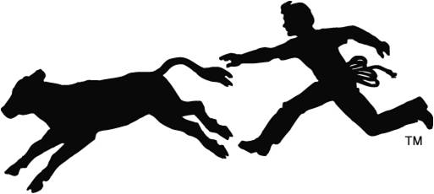

THREE SHOWS, THREE JUDGES, ONE RING!!!
All three shows sanctioned by AJCA

Register early!!!
Early entry deadline: Thurs., MAY 17
Early entry fee: $30 per head covers all shows
$15 showmanship covers all shows

Entry fee on day of show: $45 per head covers all three shows; showmanship remains the same fee

Show begins at 10 a.m.
Registration from 7 a.m. to 9 a.m.
Prizes in one ring for Supreme Heifer, Bull and Steer as well as showmanship. In addition, every exhibitor will receive a gift from the show management.

Other shows are points only.

Concession stand available on site.

