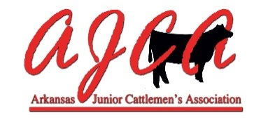
Miss AJCA & AJCA Princess
Guidelines & Criteria

Purpose: The purpose of Miss AJCA & the AJCA Princess is to promote AJCA & the livestock industry whenever and wherever possible (store openings, demonstrations, livestock shows, field days, meetings, cattlemen’s events, etc.).
Requirements: Must be a resident of Arkansas. Must be an AJCA member in good standing. Miss AJCA must be between the ages of 14-21 by October 1 of the year seeking selection. AJCA Princess must be between the ages of 9-13 by October 1 of the year seeking selection.
Prize Package: Arkansas Jr. Cattlemen’s Association will provide a crown/tiara and sash. Funding will not exceed $150 per position.
Selection & Coronation: The selection and coronation will take place during the Thanksgiving Classic AJCA sanctioned show.
Selection Process: Miss AJCA and the AJCA Princess will be selected by an application process and interview. Interested parties should complete an application and forward it to AJCA Breed Representative Chairperson by the required application date of November 1, 2018.
Miss AJCA and the AJCA Princess will be selected by a committee of three people that will include the AJCA Breed Representative Committee Chairperson, two AJCA Board members and one outside person.
Applicants for Miss AJCA and the AJCA Princess should complete the official application.
Supervision: Miss AJCA and the AJCA Princess will be under the supervision and direction of the Arkansas Jr. Cattlemen’s Association. Specifically, they will be under the direction of the AJCA Breed Representative Chairperson.
Term: Miss AJCA and the AJCA Princess shall reign beginning at the AJCA Thanksgiving Classic the year of being selected through November of the following year at which time she will crown her successor at the Thanksgiving Classic.
Miss AJCA and the AJCA Princess could serve more than one term. However, would not receive a new crown/tiara for additional terms.
Expectations: While representing the Arkansas Jr. Cattlemen’s Association, western, show ring, or dressy school/church wear attire will be worn by the representatives (no T-shirts, flip flops, tennis shoes or shorts). When appropriate a suit or dress suitable for particular occasions may be required. When representing the Association, the Miss AJCA and the AJCA Princess shall wear her sash & crown.
Miss AJCA and the AJCA Princess should plan to attend portions of the Arkansas State Fair, the Arkansas State Fair Spring Livestock Show, various AJCA sanctioned shows where they may be asked to hand out ribbons and awards as well as appearing in backdrop photos. Miss AJCA and the AJCA Princess may also, if asked, represent the Association at other county, district, and state events that she can attend by handing out ribbons and awards during cattle shows. Miss AJCA and the AJCA Princess may work cooperatively with other breed association’s breed representative during livestock events.
Miss AJCA and the AJCA Princess will conduct herself in a responsible and professional manner while representing the Association.
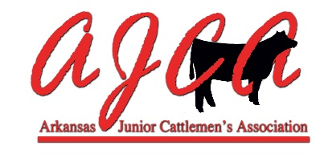
Miss AJCA & AJCA Princess Official Application

Name: ____________________________________________________
Birth date: __________________________________________________
Address: ___________________________________________________
__________________________________________________________
Applicant Cell Phone #: _________________________________________
Applicant Email Address: ________________________________________
Parents/Guardian Names: ________________________________________
Parent Cell Phone #: ___________________________________________
Parent Email Address: __________________________________________
Years in AJCA: ___________ AJCA Membership Number: ________________
Name of School _______________________________________________
Grade Level: __________________________
Miss AJCA: Attach a typed double spaced essay of 500 words or less containing items #1-#5 below. AJCA Princess: Attach a typed double spaced or hand written essay of 250 words or less containing items #1-#5 below.

1. Introduce yourself.
2. Outline your involvement in the cattle industry and AJCA.
3. Special leadership skills, club involvement, breed association involvement or community service activities you are or have been involved with.
4. Why do you want to be Miss AJCA or the AJCA Princess?
5. Your goals/plans for your future.
Application and required essay should be returned by November 1, 2018 prior to:
Tracie Mangrum, Chairman
Miss AJCA & AJCA Princess
90 GR 419 Road
Marmaduke, AR 72443

Contact Tracie at 870.565.8878 or betmangrum@gmail.com with questions.

